***EXPERIMENT 05***

**Applications of Diode**

**Objective:** To investigate the characteristics of diode half wave rectifier, diode clipping and diode clamping circuits.

**Equipment Required:** Function generator, DSO, Silicon diode, a large electrolytic capacitor, a non-electrolytic capacitor (0.01-0.1µF), breadboard.

**Note:** DSO should be in DC coupling mode. (To set channel 1 in DC coupling mode, press 1, select coupling in the menu and set it to DC.)

**Introduction:** A rectifier is an electrical device that converts alternating current (AC) to direct current (DC), a process known as rectification. Rectifiers have many uses including as components of power supplies and as amplitude modulation detectors (envelope detectors) of radio signals.

In half wave rectification, either the positive or negative half of the AC wave is passed, while the other half is blocked. Because only one half of the input waveform reaches the output, it is only 50% efficient if used for power transfer. Half-wave rectification can be achieved with a single diode in a single-phase supply

Clipping circuits clip signals above a selected voltage level, whereas clamping circuits shift the DC voltage of a waveform. Many wave shapes can be produced with the proper application of these two important diode functions.

**Experiments to be performed**

1. Diode Half wave rectifier:

(a)Connect the series circuit comprises of the function generator, diode and resistor (10kΩ) as in Fig. 5.1. Set the oscillator frequency to about 500Hz and a convenient amplitude (about 5V).

(b)Observe the oscillator waveform across the resistor on the DSO (Record the waveforms).

(c)Measure the peak and dc value of both input as well as output waveforms.

(d)Repeat the observations for an input voltage of one-tenth of the previous case.

(e)Connect a large electrolytic capacitor across the resistor. Repeat your observations.

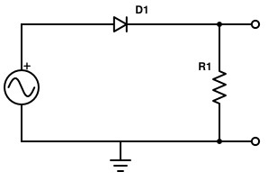

# Fig 5.1 Circuit diagram of a diode half wave rectifier with R1=10KΩ

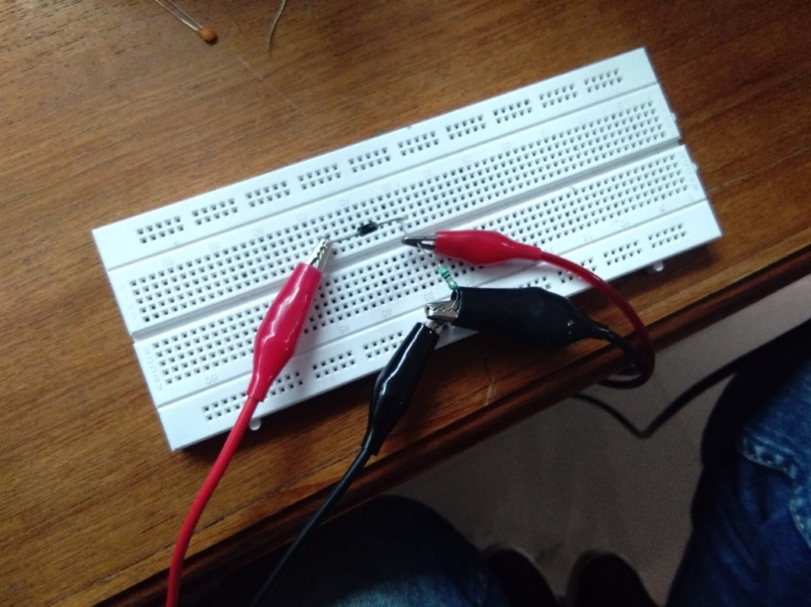

Snapshot of the breadboard with the circuit connected as in Fig. 5.1

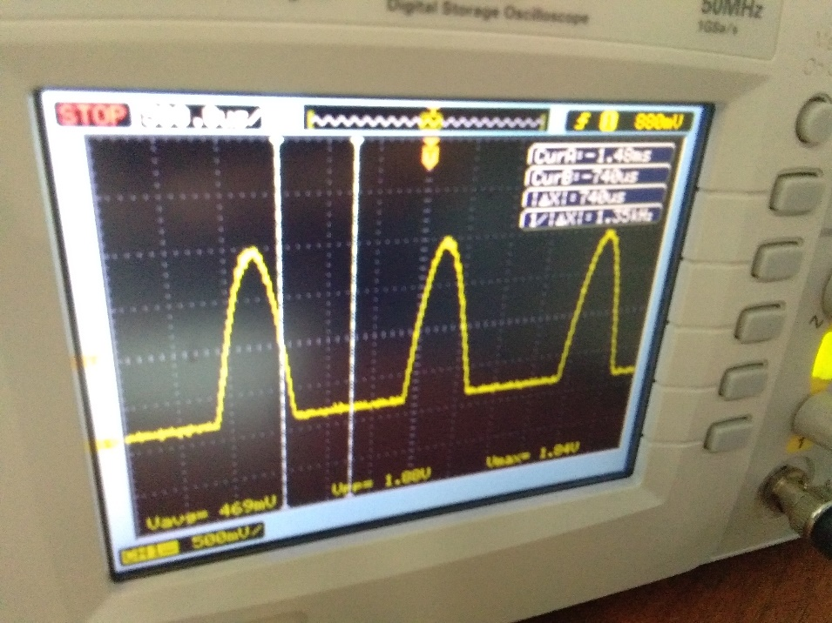

snapshots of the DSO screen with waveform across the resistor

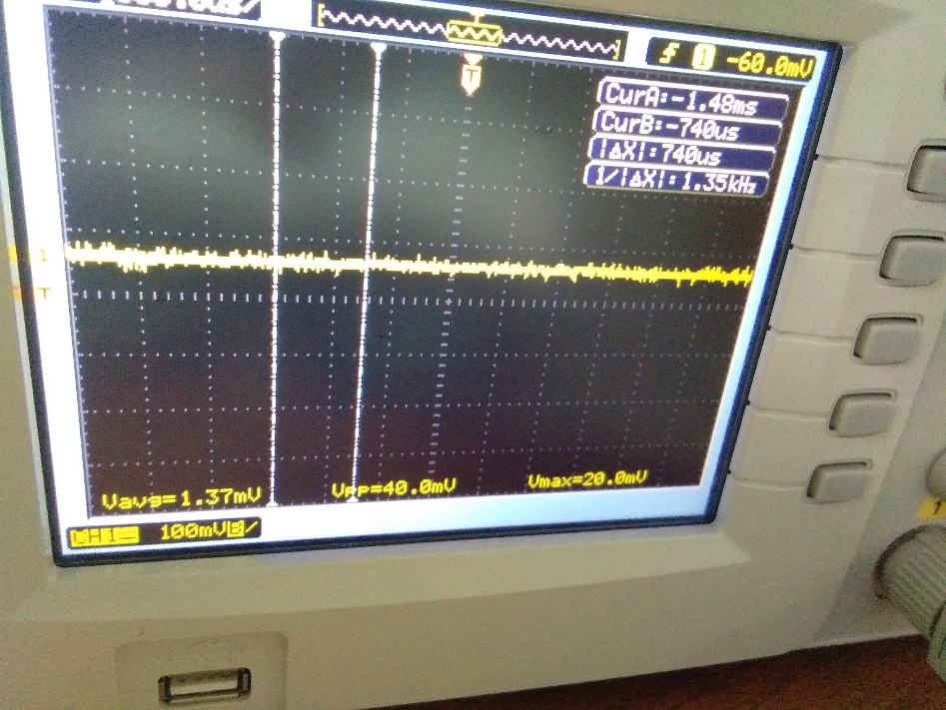

output at one-tenth input voltage

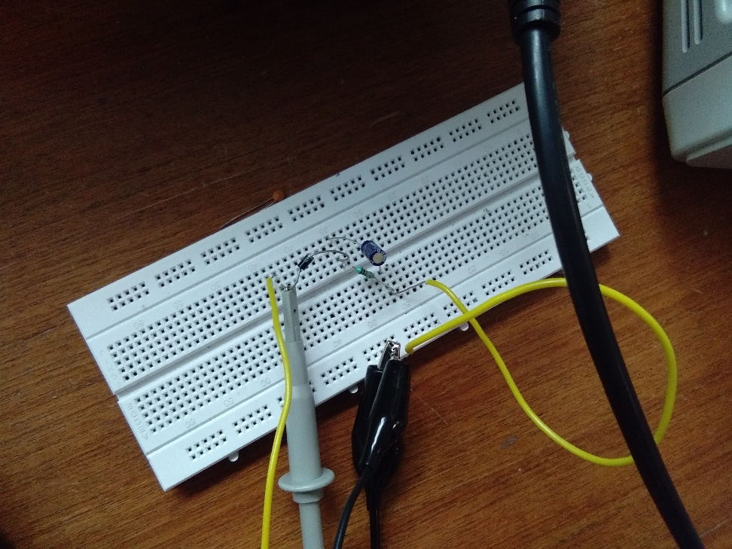

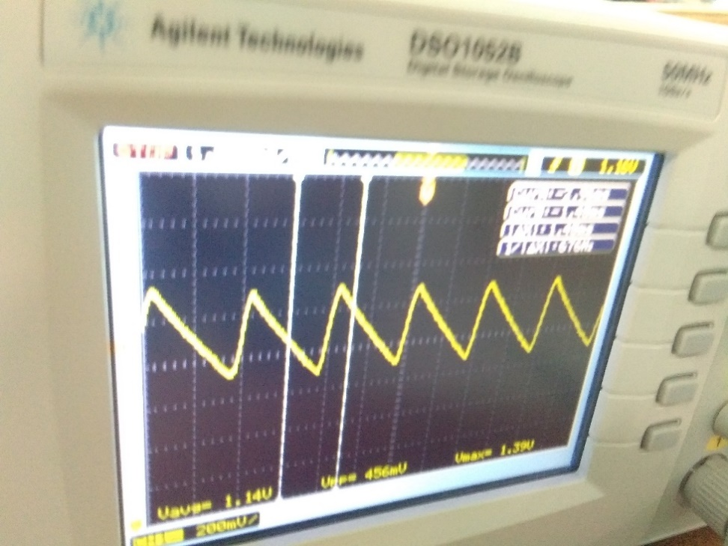

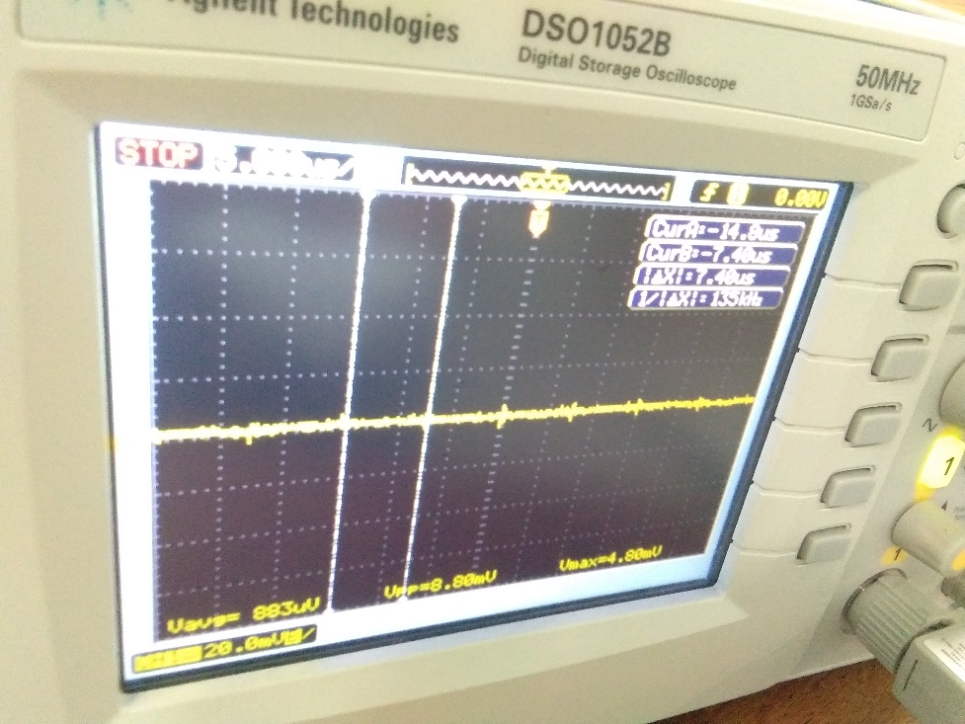

repeated measurements with a capacitor connected at the output

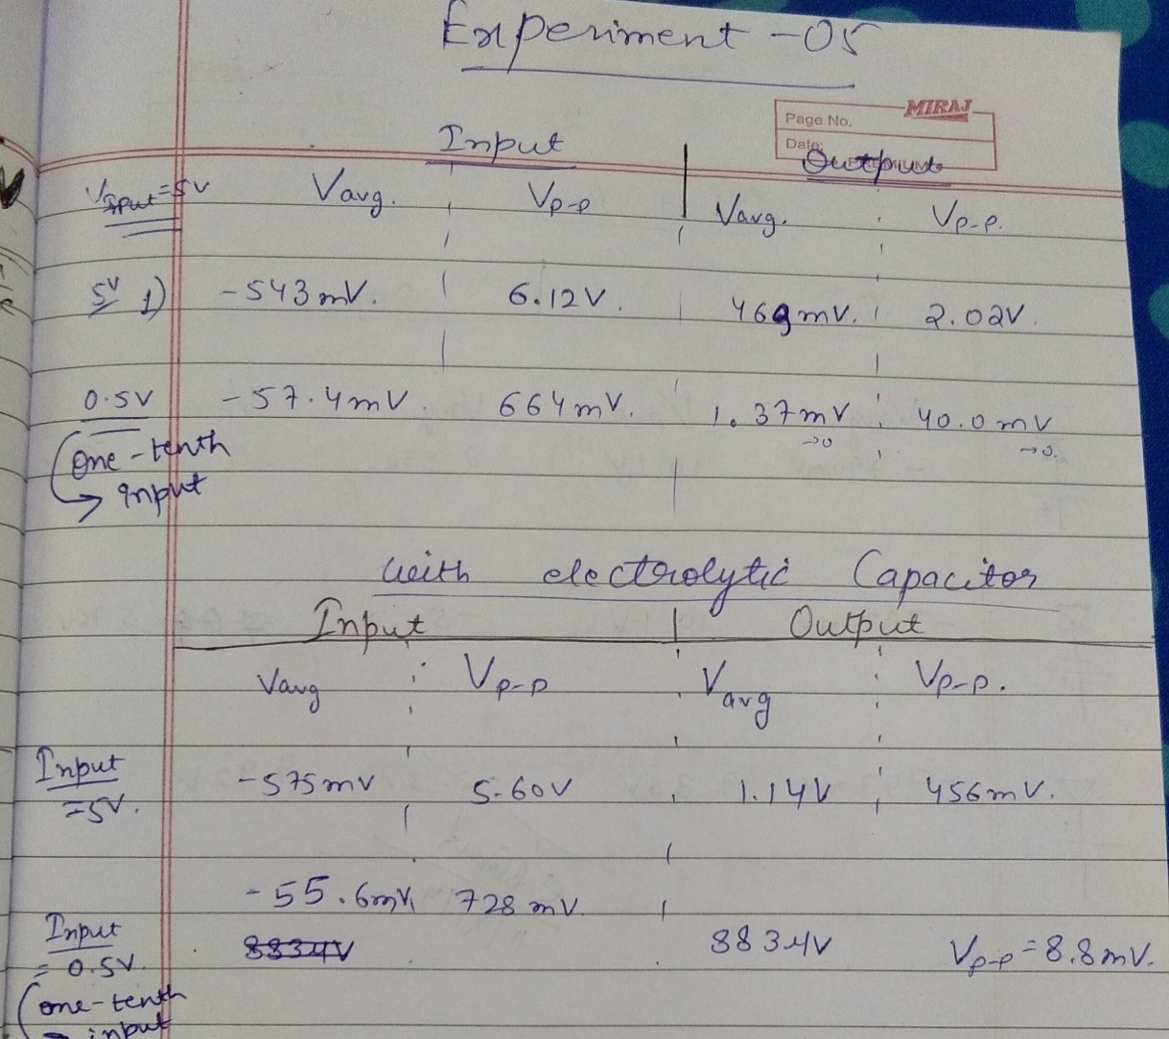

Measured peak and dc values of the input and output, measured peak and dc values of the input and output at one-tenth input voltage and repeated measurements with a capacitor connected at the output

2. Diode Clipping Circuit:

(a)Connect the series circuit of the Function generator, diode, dc source set to about 2V and resistor (10kΩ) (See Fig. 5.2). Set the oscillator frequency to about 500Hz and a convenient amplitude (about 5V)

(b)Observe the oscillator waveform and the waveform across the diode & dc source on the DSO

(c)Measure the peak and dc value of both waveforms.

1. Reverse the diode polarity and repeat the observations.
2. Reverse the source polarity and repeat the observations.

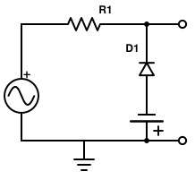

**V**

**Fig 5.2 Circuit diagram of a diode clipper with V = 2V, R1 = 10KΩ**

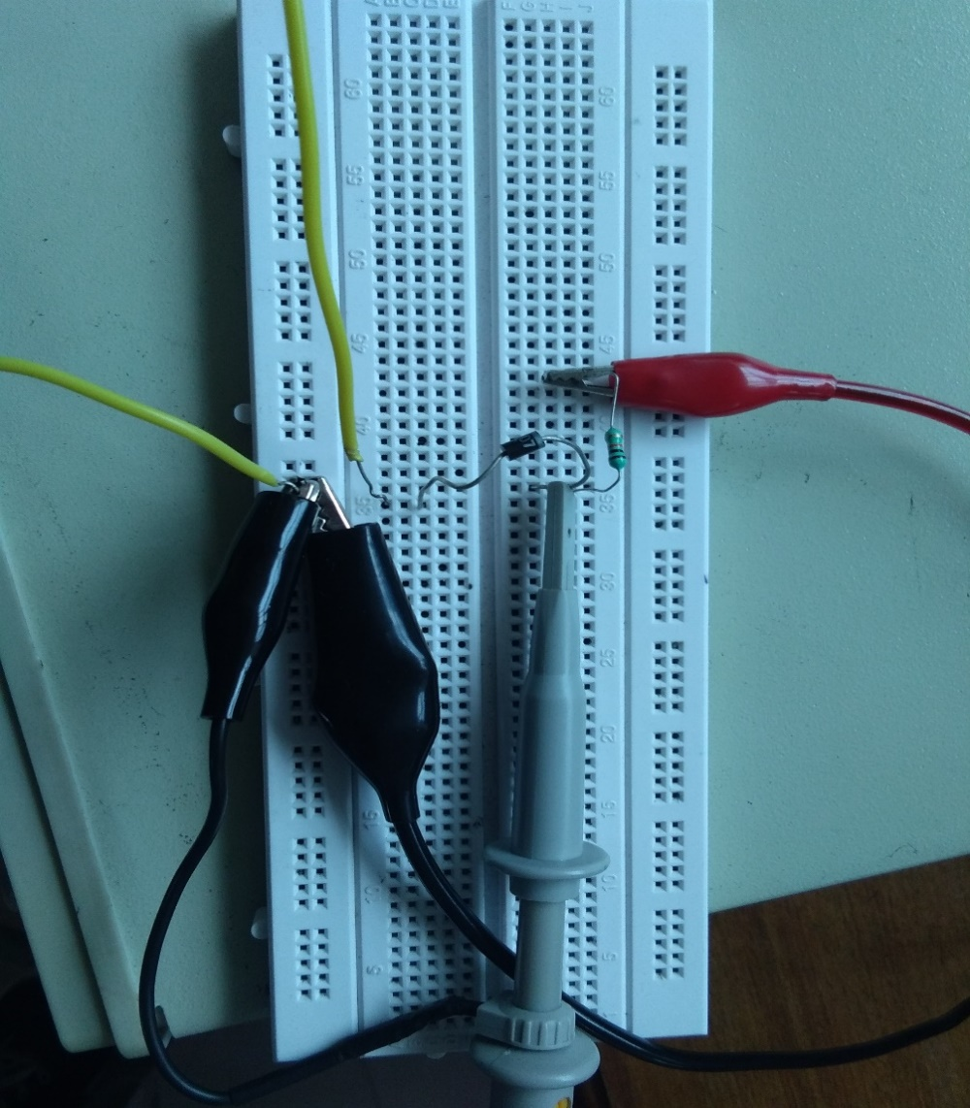

Snapshot of the breadboard with components connected as per Fig. 5.2 in the manual

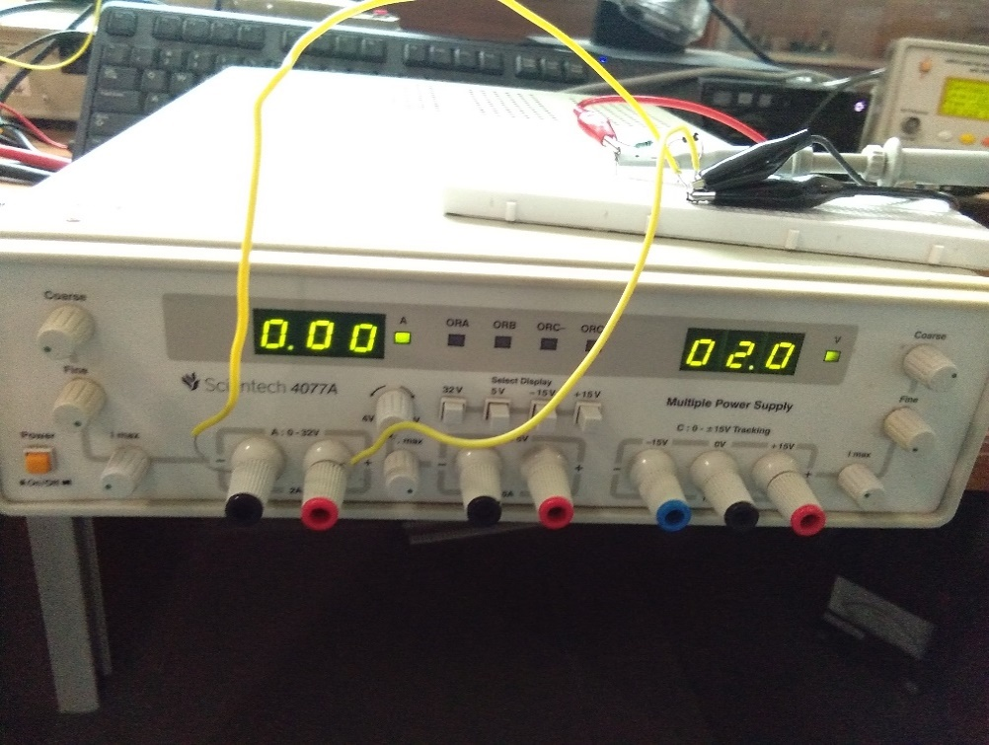

Voltage source V=2V

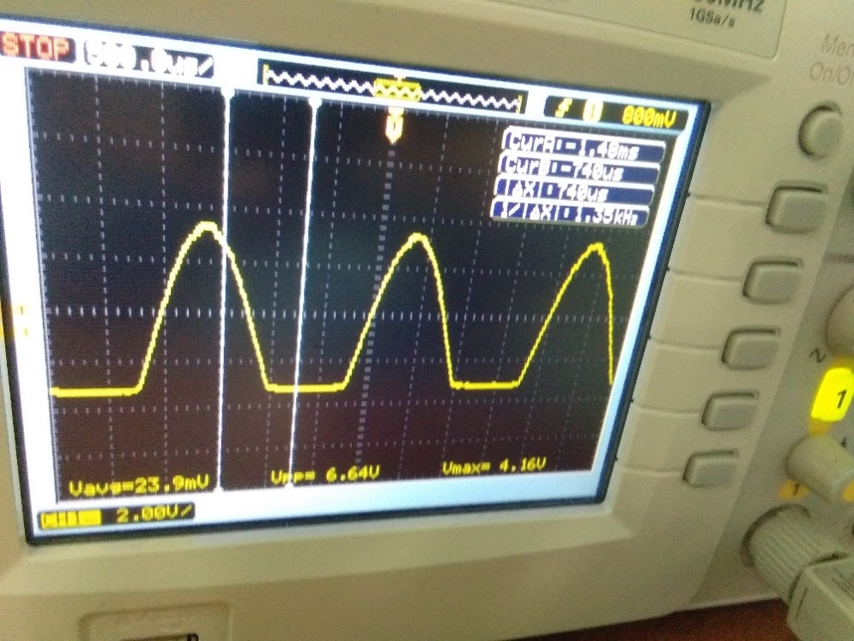

Snapshot of DSO screen with waveforms across the diode and source

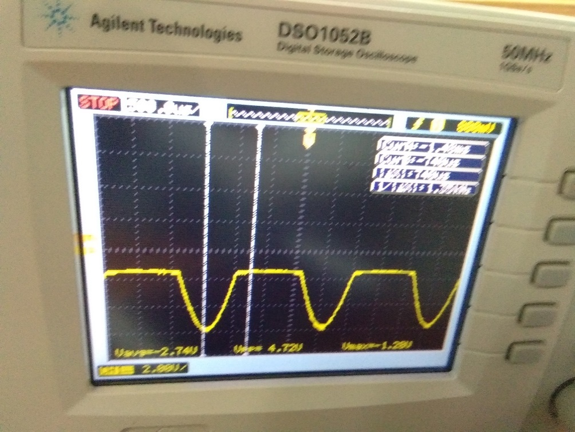

repeated experiment with reversed diode polarity

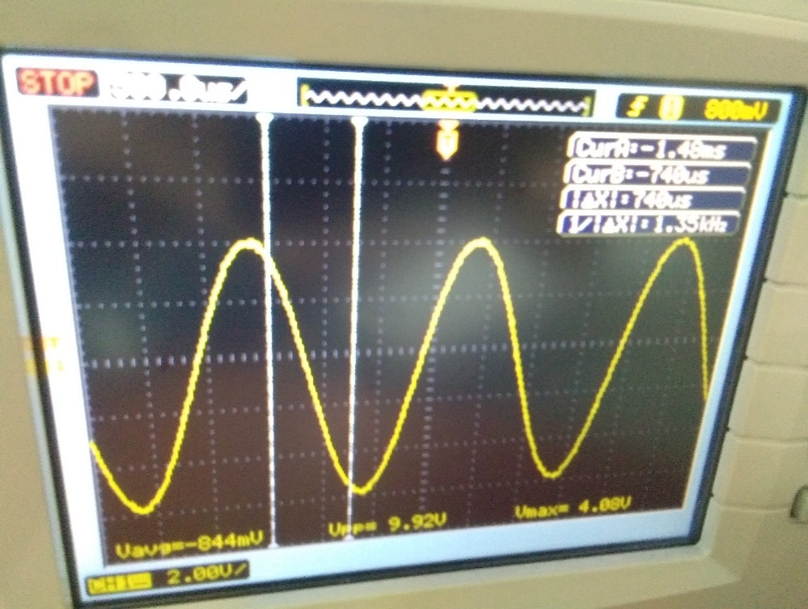

repeated experiment with reversed source polarity

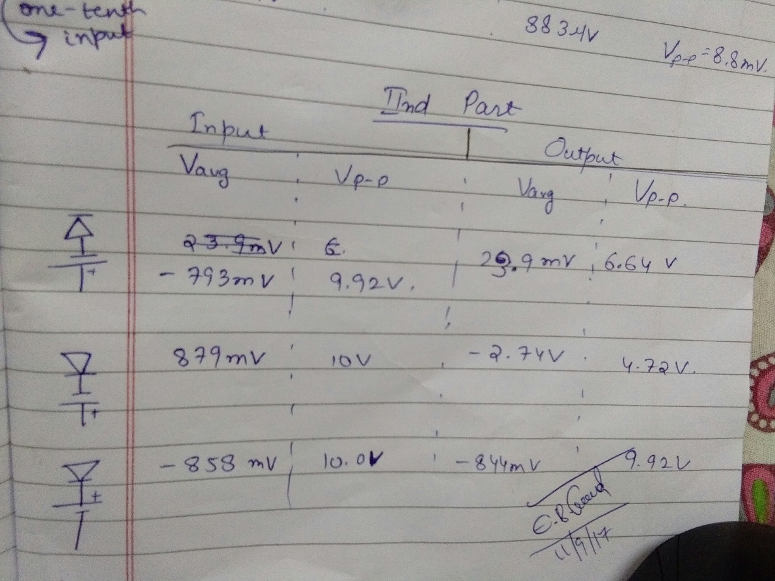

measured peak and dc values of output and input waveforms

3. Diode Clamping Circuit:

1. Connect the series circuit comprising of the function generator, diode, dc source set to about 2V and capacitor (0.01µF) (See Fig. 5.3). Set the oscillator frequency to about 500Hz and a convenient amplitude (about 5V).
2. Observe the oscillator waveform and the waveform across the diode-dc source bench on the DSO (Record the waveforms).
3. Measure the peak and dc value of both waveforms.
4. Reverse the diode polarity and repeat the observations.
5. Reverse the source polarity and repeat the observations.

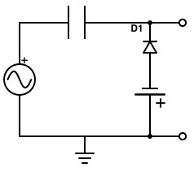

**V**

**C**

# Fig 5.3 Circuit diagram of a diode clamper with C = 0.01µF, V = 2V

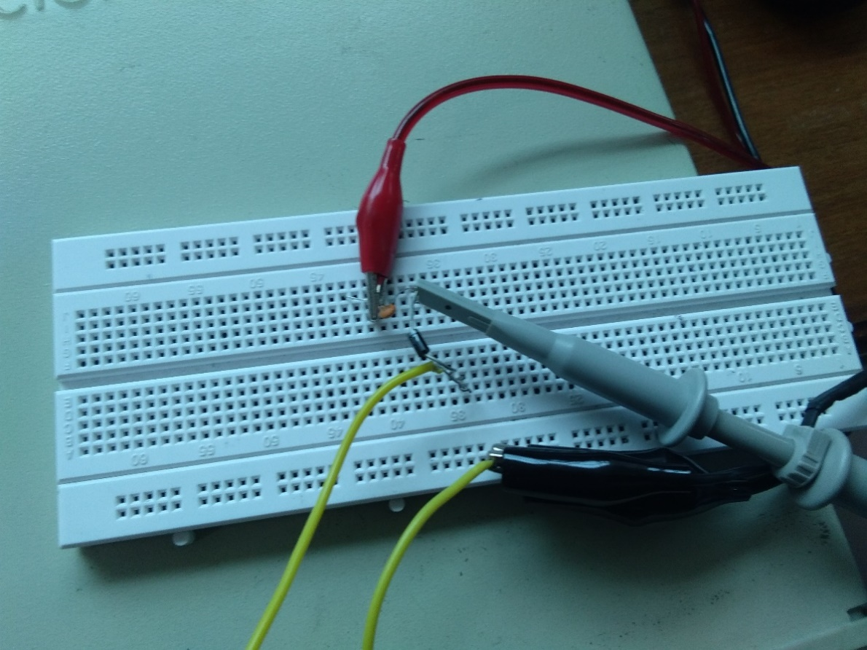

Snapshot of the breadboard with components connected as in Fig. 5.3 of the manual

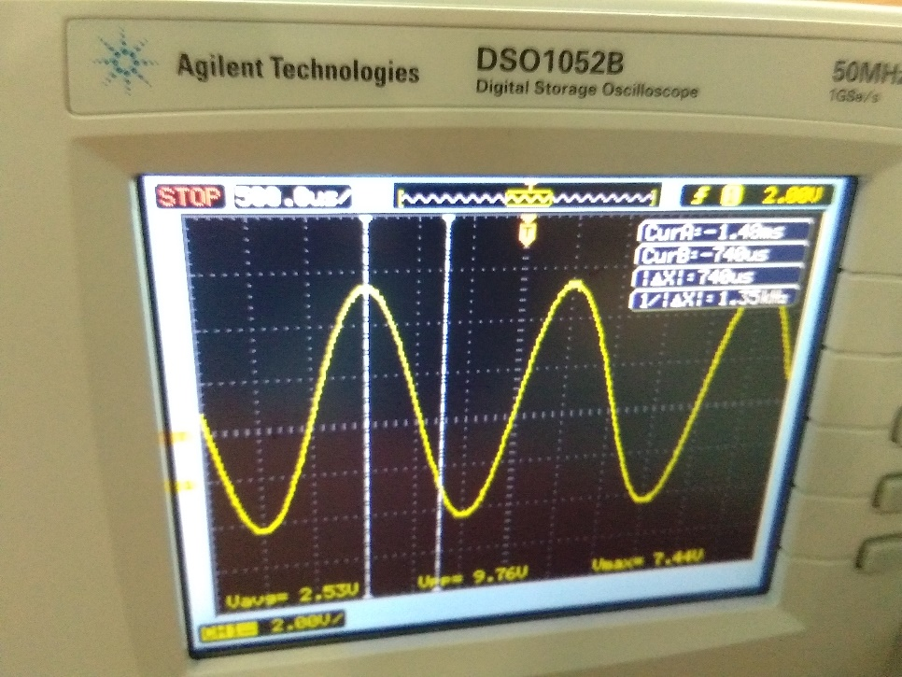

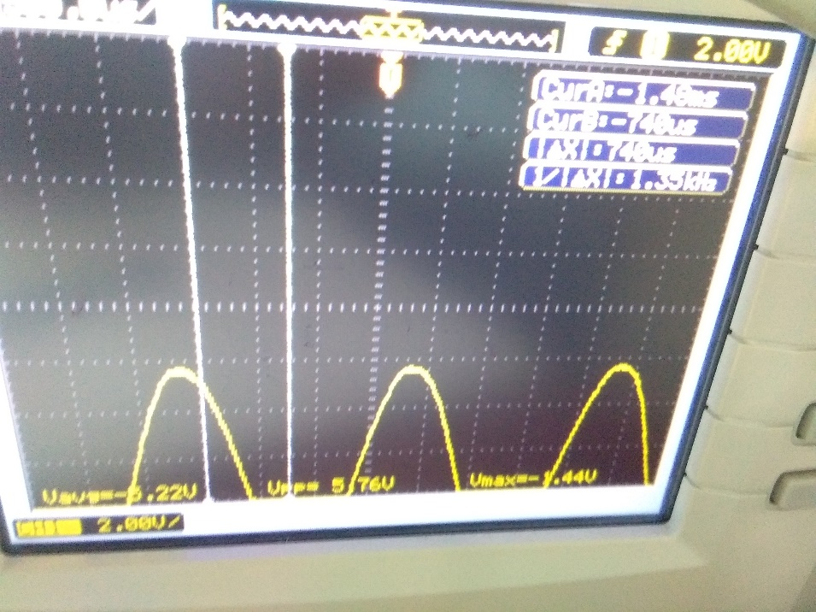

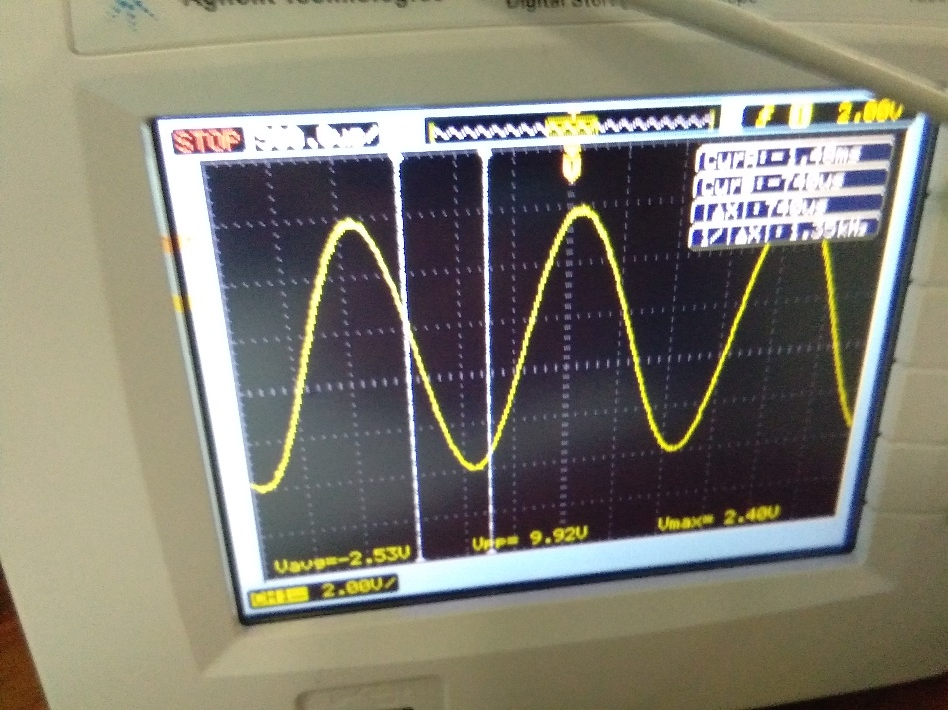

Snapshot of DSO screen with waveforms across the diode and source: in the initial position, with the polarity of diode reversed and then with the polarity of source reversed.

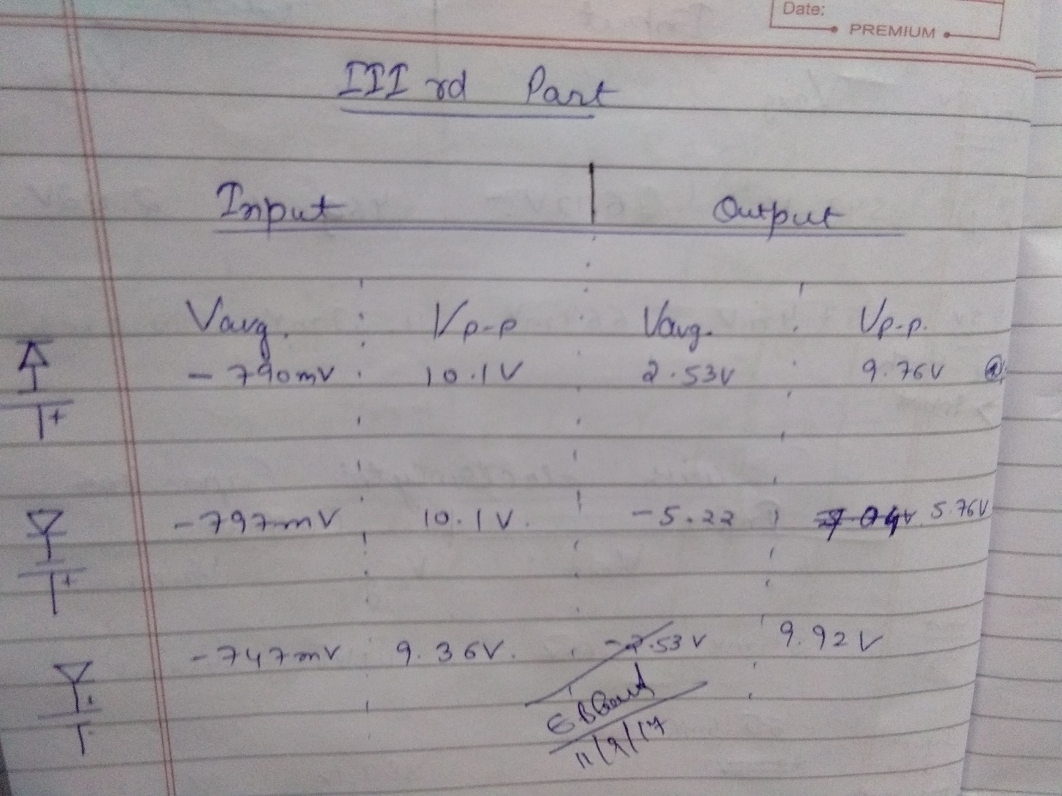

Measured peak and dc values of the output and input.

# 

**Conclusion:**

In the above experiment, we studied the applications of Diode as a rectifier, in a clipping circuit, and clamping circuit. We realized that as a rectifier, when only one diode is used in the circuit, can be used as a half-wave rectifier, which allows only one part of the current cycle (positive or negative). The diode does not allow the other half of the input wave and hence gives us rectified voltage. In clipping circuit, a diode with a DC source can be used to clip a part of the input signal. The polarity of diode determines which half would be clipped and the voltage of the DC source determines the threshold voltage above(/below) which the wave signal is clipped. In clamping circuit, the voltage (as per theory) is shifted above or below its original mean position, by half the peak-to-peak value. We observe the same in the DSO screens. Thus, we see that diodes can be efficiently used to rectify, clip or clamp AC signals.